1. 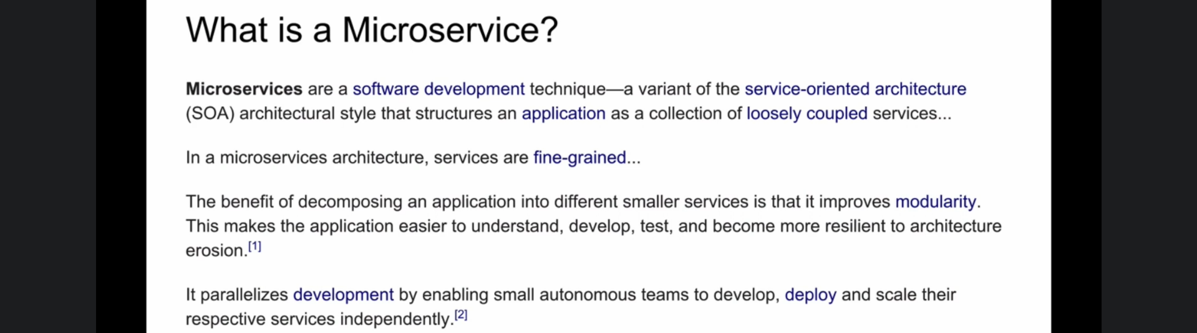
2. What are microservice?  
   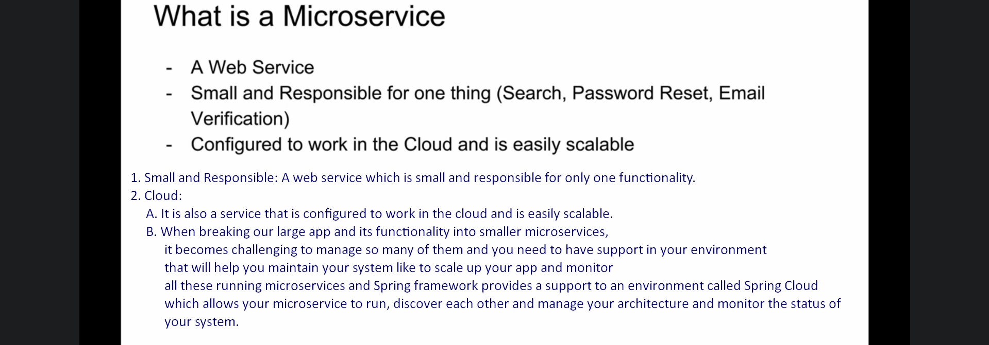
3. Time: 1:50